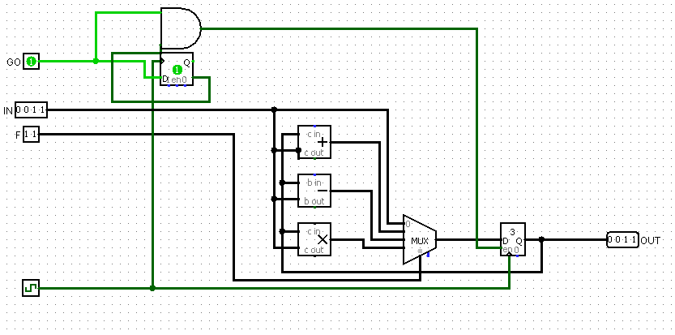

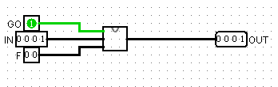

ADDITION (2 SIGNED & 2 UNSIGNED)

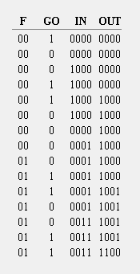

SUBTRACTION (2 SIGNED & 2 UNSIGNED)

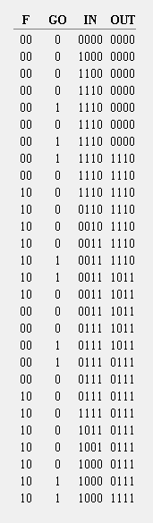

MULTIPLICATION

